**CRT 360: Advanced Prototyping**

**Game Pad - Concept Development**

**Part I: Ideation**

***1. Describe the overall idea behind your game:***

I am still not sure on the story behind my game but will update this soon with a story. I know I would like the protagonist to be me and the final boss to be my bearded dragon, Norbert. I would like for the setting to be like a Zelda dungeon, maybe exploring a deep cave or something.

***2. Cite three references for your game and describe the influence they will have on your game concept. Support your descriptions with visuals.***

Links Awakening: This is the main game I want to take inspiration from. This is a classic from my childhood and a staple when I think of a top down adventure game. The main thing I think of from this game is the first dungeon. I would like to keep the esthetics of the first dungeon (being a dark cave with torches) and have a final boss at the end of the dungeon. I would like to have gameplay elements from Zelda as well, like boss door keys, shields, etc. I am also going to use a HUD similar to links awakening, and have a simple bar at the bottom, displaying health and items.

Lenna’s Inception: This is a game I found on steam a while back (it is based off of Zelda (looks like links awakening) and would like to use the graphics as inspiration. They remind me of links awakening but mixed with Stardew valley. I don’t know if it is possible to get that amount of detail, but I want to mess around with it. The game also looks like it has inspiration from the creator’s life, so I would like to try that as well. This is why I would like to make Norbert (my bearded dragon) as the final boss and me as the protagonist.

Star Fox 64: I like the idea you had in class about having facial expressions for your character like in doom. I was thinking about doing this but in the star fox 64 style in the bottom left.

***3. Create at least 3 characters for your game using reference images and sketching as necessary.***

Boss: Norbert (random pixel art as inspiration)

Protagonist: Jeff

(Stardew valley character for inspiration)

Enemies: undecided but some kind of reptile enemy (zelda as inspiration)

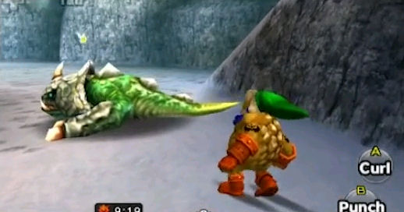

Snapper (Zelda) Dodongo (Zelda) Dinolfos (Zelda)

***4. Create at least 6 playing areas for your game and include the scans below. You can use the level designer template here to help:*** [***Game Pad Level Template***](https://docs.google.com/document/d/1laBD5Sh8APvEjRW4q-PTSdQMtImiYxuJ0KQ17z-nhfo/edit?usp=sharing)

Room 1 Room 2 Room 3

Room 4 Room 5 Room 6

Room 7 Room 8

***5. Describe the controls that will help the user interact with the game (the Game Pad includes 1 analog joystick and 4 push button controls)***

|  |  |
| --- | --- |
| Joystick X | Moves the character Horizontally |
| Joystick Y | Moves the character Vertically |
| A | Interacts with doors/chests |
| B | Attacks with sword |
| X | Swaps between shield/propeller hat |
| Y | Uses shield/propeller hat |